* **Covering letter – the letter must contain: why the submission is appropriate for publication in Public Health; what is known about the topic discussed; what your study adds; and confirmation that the paper has not been published elsewhere**

Porto Alegre, November, XX, 2023.

Andrew Lee, MD MFPH MRCGP and Joanne Morling, MBChB, MSc, PhD

Editors-in-Chief

Public Health Editorial Office  
The Royal Society for Public Health

Dear Editors:

Please find enclosed our manuscript entitled “The Burden of High Fasting Plasma Glucose in South American Countries, 1990–2019: A Systematic Analysis for the Global Burden of Disease Study”, which we would like you to consider for review and possible publication in the special Public Health issue *The Burden of Disease in South America*.

Our manuscript reports the investigation of an original research question that generates new and impactful knowledge about the burden of disease in South America, using Institute for Health Metrics and Evaluation (IHME) data from the ‘Global Burden Diseases’ (GBD) study.

High prevalenceand burden of diabetes have been reported in the Americas. Still, a comprehensive analysis of the high fasting plasma glucose burden and the compound effect of severity and prevalence for the South American region is scarce.

Given the heterogeneity of diabetes morbidity and mortality burden across countries in America, it is essential to have more detailed data for more accurate planning of public health policies. This article describes the burden of hyperglycemia in South American countries from 1990 to 2019. Furthermore, we aim to evaluate the relationship of HFPG to the level of socioeconomic development of these countries.

This paper has not been published elsewhere.

Looking forward to your reply, we thank you very much in advance.

Yours sincerely,

Rita Mattiello, on behalf of the co-authors.

**Title page**

The burden of high fasting plasma glucose in South American Countries, 1990–2019: a systematic analysis for the Global Burden of Disease Study

Anelise Decavatá Szortyka, MDa, Sergio Espinozab, Bruce Bartholow Duncan, PhDa,, Bárbara Niegia Garcia de Goulart, PhDa,c, Rodrigo Citton Padilha dos Reis, PhDa,d, Rita Mattiello, PhDa,b,*

Ewerton, y Liane and Mohsen

aPrograma de Pós-graduação em Epidemiologia, Universidade Federal do Rio Grande do Sul, Porto Alegre, Brazil

b Faculdade de Medicina, Universidade Federal do Rio Grande do Sul, Porto Alegre, Brazil

c Instituto de Psicologia, Serviço Social e Saúde e Comunicação Humana, Universidade Federal do Rio Grande do Sul, Porto Alegre, Brazil

d Departamento de Estatística, Universidade Federal do Rio Grande do Sul, Porto Alegre, Brazil

*Corresponding author. Prof. Rita Mattiello, Faculdade de Medicina, Universidade Federal do Rio Grande do Sul, Porto Alegre, Brazil. Tel.:+5551993273252.

E-mail address:[rita.mattiello@ufrgs.br](mailto:rita.mattiello@ufrgs.br)

**Blinded manuscript**

**Abstract**

**Objective:** to describe the burden of hyperglycemia, characterized by the Global Burden of Disease Study as high fasting plasma glucose (HFPG), in South American countries from 1990 to 2019

**Study design**: epidemiological study.

**Methods:** The burden attributable to HFPG in adults aged 25 years or older in twelve South American countries from 1990 to 2019 using the Global Burden of Disease (GBD) 2019 estimates. A systematic analysis was performed on mortality and morbidity data to estimate disability-adjusted life years (DALYs), years of life lost (YLLs), years lived with disability (YLDs), and summary exposure value (SEV). We also evaluated the data across the Socio-Demographic Index (SDI). All estimates were for both sexes, age-standardised, and 95% uncertainty intervals (95%UI) were described.

**Results:** The burden of HFPG is large and growing in South America. In 2019, Guyana had the highest rate of YLLs (5,419.6; 95%UI 4,115.1-6,924.2), YLDs (1,212.5; 95%UI 838-1,649.2), DALYs (6,632.1; 95%UI 5,237.1-8,243.3), SEV (23.2; 95%UI 21.1-25.2), and deaths (254.5; 95%UI 193.9-324.1). Peru had the lowest rates of YLLs (746.5; 95%UI

538.6-1,035.4), DALYs (1,143.1; 95%UI 889.2-1,445.9), SEV (7.7; 95%UI 6.6-8.9), and deaths (41.2; 95%UI 29.6-57), whereas Uruguay had the lowest rate of YLDs (357.9; 95%UI 242.4-485.6). Between 1990 and 2019, in most countries, DALYs, YLLs, and deaths decreased, while the SEV and YLDs increased.

**Conclusions:**South America´s HFPG burden is large and heterogeneous across countries. While its mortality has decreased, the underlying cause – increased hyperglycemia – has risen, and with it, an increase in disability. These changes indicate a shift of the burden from mortality to morbidity and health systems must abide by the added workload

**Keywords:** hyperglycaemia, disability-adjusted life years, life Expectancy

ler comment do prof sobre graphical abstract

**Introduction**

OI, TODOS AS REFERÊNCIAS TÊM SEUS TRECHOS EM COMENTÁRIOS. POR FAVOR, VAMOS DEIXAR ATÉ AS ÚLTIMAS REVISÕES PARA FACILITAR CONFERIR AS CITAÇÕES. DEPOIS TIRAMOS =))) OBRIGADA ;*

Diabetes is one of the leading causes of mortality and disability globally. In 2021, there were 529 million (95% uncertainty interval [UI] 500–564) people living with diabetes worldwide, with a predicted rise to 1.31 billion (1.22–1.39) by 2050 (1) **(Global regional national, 2023)**. Hyperglycemia, defined in the Global Burden of Disease context as High Fasting Plasma Glucose (HFPG), is an essential risk factor for diabetes. Diabetes and, to some extent, lesser hyperglycemia are independent risk factors for numerous adverse outcomes (2) **(Liang, 2022)**. In the Americas in 2019, diabetes and high fasting plasma glucose were responsible for 2266 (1930-2649) and 4401 crude DALYs (3685-5265) per 100,000 adults, respectively, with considerable variation across regions (3) **(Cousin, 2022)**. [Kanyin Liane Ong](https://pubmed.ncbi.nlm.nih.gov/?term=Ong+KL),

High prevalence and burden of diabetes have been reported in the Americas (3) **(Cousin, 2022)**. Still, a comprehensive analysis of the high fasting plasma glucose burden and the compound effect of severity and prevalence for the South American region is scarce.

Given the heterogeneity of diabetes morbidity and mortality burden across countries in America, it is essential to have more detailed data for more accurate planning of public health policies. This article describes the burden of hyperglycemia in South American countries from 1990 to 2019. Furthermore, we aim to evaluate the relationship of HFPG to the level of socioeconomic development of these countries.

**Methods**

We analyzed the burden of HFPG in adults aged 25 years and older in twelve South American countries (Argentina, Bolivia, Brazil, Chile, Colombia, Ecuador, Guyana, Paraguay, Peru, Suriname, Uruguay, and Venezuela) from 1990 to 2019 using estimates from GBD 2019. The territory of French Guyana was not included since it is part of France.

HFPG is classified as a risk factor in GBD data. GBD 2019 organizes risk factors into four hierarchical categories. At the highest level (level 1), risk factors are split into behavioral, environmental, occupational, and metabolic groups. HFPG is a level 2 metabolic risk factor for GBD (4) **(Supplement app1 87 risk)**. It described the risk and burden of HFPG at the diabetes level, both for type 1 and type 2 disease, and that due to lesser degrees of HFPG.

The GBD methodology for defining HFPG was described elsewhere, in the official appendices of the group, but briefly mentioned here. The HFPG was measured with differing types of hyperglycemia – fasting glucose, 2 hour glucose within an oral glucose tolerance test (2h glucose), and glycated hemoglobin (HbA1c) **(FONTE RITA??? prof, procurei possíveis artigos, mas não achei)**.

The HFPG was measured as the mean fasting plasma glucose in a population, a continuous exposure in units of mmol/L. Since plasma fasting glucose is a continuous variable, HFPG is defined as any level above the theoretical minimum risk exposure level TMREL, which is 4.8-5,4 mmol/L (4) **(Supplement app1 87 risk, 2020)** or 86,4-97,2 (5) **(Anamag FT, 2023)**, depending on the outcome being considered.

The methods for calculating the HFPG burden have been described elsewhere, but in brief, it is calculated by joining the estimated excess risk of undesirable outcomes at different levels of hyperglycemia with estimates of the frequency of these levels across the distribution of hyperglycemia.

The estimated excess risk of HFPG is obtained through literature review of risk across the spectrum of hyperglycemia across the HFPG-outcome cause pairs. We estimated the burden of disease directly associated with the risk factor HFPG. Posteriorly, we described the burden of HFPG due to all causes, as well as the fifteen conditions attributable to HFPG, level 3, in the 2019 GDB Study as follows: diabetes, ischemic heart disease, stroke, chronic kidney disease, alzheimer's disease, tracheal, bronchus and lung, cancer, colorectal cancer, breast cancer, pancreatic cancer, tuberculosis, blindness and vision loss, peripheral artery disease bladder cancer, ovarian cancer, liver cancer (6) **(Wirth, 2023)**.

The HFPG burden was assessed for both nonfatal and fatal estimation. Fatal events was estimated as years of life lost (YLLs) due to premature death. Non-fatal events were estimaed as years lived with disability (YLDs) and disability-adjusted life years (DALYs) lost, which is the sum of YLLs and YLDs. YLLs are calculated subtracting the age at death from the longest possible life expectancy for a person at that age. YLDs are calculated as the prevalence of the disabilities (outcomes and their sequela) for those with HFPG multiplied by the disability weights for those conditions. The disability weight expresses the relative valuations of the health state caused by the diverse disabilities on an interval scale. In the GBD, health state valuations lie between 0 (full health) and 1 (states equivalent to death) (7) **(supplement 369 diseases)**.

To estimate the extent of population exposure to risk factors, GBD employs the Summary Exposure Value (SEV), which is expressed as a continuous variable (3) **(Cousin E, 2022)**. The SEV for HFPG is calculated as the weighted prevalence of hyperglycemia, in which each level of glucose above the TMREL is weighted by the excess risk of outcomes produced at that level (8) **(Supplement Cousin E, 2022)**. It varies from 0% to 100%, zero indicating minimal risk, and 100% maximum possible risk. The SEV thus provides an excess risk-weighted prevalence (9) **(Murray 87 risk factors, 2020)**. Though not useful for comparisons across risk factors, it permits comparison of exposure to a given risk factor across different populations and at different times.

The Sociodemographic Index

The Socio-demographic Index (SDI) is a composite indicator of social development (4) **(Supplement app1 87 risk, 2020)**. It is derived from the average of lag-distributed income per capita, total fertility rate in women under 25 years and average education in people over 15 years in populations (3,4) **(Cousin E 2022) (Supplement app1 87 risk, 2020)**. The closer its value is to zero, the worse the estimated social development, with a value of zero representing a theoretical minimum level of socio-demographic development relevant to health issues and a value of one representing a theoretical maximum level of development (4) **(Supplement app1 87RF, 2020)**.

All estimates were performed for both sexes, age-standardized, and generated from data available from <http://ghdx.healthdata.org/gbd-results-tool>. The figures were done using the R package version 4.02.

**Results**

~~Burden of HFPG in South American countries~~

In 2019, the age-standardized death rate and morbidity attributable to HFPG was high.

The rate ~~total number~~ of deaths attributable to HFPG was highest in Guyana ~~(254.5 [IU95% 193.9 to 324.1])~~, Suriname ~~(147.5 [IU95% 116.9 to 185.5])~~, and Venezuela ~~(126.4 [IU95% 90.8 to 172.6])~~. In contrast, the lowest numbers were found in Peru ~~(41.2 [IU95% 29.6 to 57.0])~~, Uruguay ~~(54.4 [IU95% 42.5 to 70.7])~~, and Chile ~~(62.3 [IU95% 48.6 to 79.8])~~ (Table 1). Between 1990 and 2019, the age-standardized mortality rate attributable to HFPG decreased (Figure 1).

Similarly, the morbidity measures showed the highest and lowest values in the same countries. Guyana ~~(6632.1 [IU95% 5237.1 to 8243.3])~~, Suriname ~~(4219.3 [IU95% 3451.4 to 5046.1])~~, Venezuela ~~(3231.8 [IU95% 2478.8 to 4103.7])~~ had the highest DALYs, and Peru ~~(1143.1 [IU95% 889.2 to 1445.9])~~, Uruguay ~~(1316.1 [IU95% 1065.7 to 1621.1])~~, and Chile ~~(1573.0 [IU95% 1264.6 to 1926.3])~~ the lowest numbers (Table 1). There was also an overall decrease in age-standardized DALYs in South America between 1990 and 2019 (Figure 1). Most of the DALYs were due to YLDs.

In 2019, ~~Guyana (1212.5 [IU95% 838 to 1649.2])~~, Suriname ~~(1166.5 [IU95% 798.7 to 1599.5])~~, Venezuela ~~(802.9 [IU95% 547 to 1096.5])~~ also had the highest YLDs rate, and Peru ~~(396.6 [IU95% 268.5 to 544.8])~~, Uruguay ~~(357.9 [IU95% 242.4 to 485.6])~~, and Argentina ~~(479.8 [IU95% 327.5 to 660])~~ the lowest YLDs rates (Table 1). On the other hand, YLDs and SEV increased in all the countries from 1990 to 2019 (Figure 1).

The rate of age-standardized YLD per 100.000 adults has increased in South America from 1990 to to 2019. The same countries that had the highest (Guyana ~~(5419.6 [IU95% 4115.1 to 6924.2])~~, Suriname ~~(3052.8 [IU95% 2426.9 to 3789.4])~~, Venezuela ~~(2428.8 [IU95% 1748.9 to 3251.7])~~ and lowest rates (Peru ~~(746.5 [IU95% 538.6 to 1035.4])~~, Uruguay ~~(958.2 [IU95% 756.6 to 1211.3])~~, and Chile ~~(1009.5 [IU95% 811.5 to 1244.3])~~ of age-standardized DALYs showed the same pattern for YLLs, that is… rever info do yll e escrever explicação (Table 1).

As shown in Figure 2, while the age-standardized rates for mortality, YLLs and DALYs were falling overall, the all-ages rates for these metrics were consistently rising. The age-standardized YLD, in contrast with the other parameters, is rising.

Regarding the annual rate of change of age-standardized DALYs, YLLs, YLDs, deaths, and SEV overtime, Brazil, Colombia, and Guyana had a negative rate of change (shrinking burden) for DALYs, YLLs, and deaths (Argentina, Brazil, Chile, Colombia, Guyana, and Peru). In contrast, all the countries have had a positive rate of change (growing burden) for YLDs and SEV (Figure 2). There was no clear correlation between the rate of change (1990 to 2019) and SDI (2019) across countries (Figure 3).

The leading 15 Level 3 causes of global DALYs due to HFPG (see in Supplementary materials) in 1990 and 2019 were diabetes, ischemic heart disease, Stroke, chronic kidney disease, tuberculosis, lung cancer, Alzheimer's disease, colorectal cancer, breast cancer, pancreatic cancer, blindness and vision loss, peripheral artery disease, bladder cancer, ovarian cancer and liver cancer.

The percent of change for several risk factors are depicted in figure 4. HFPG features as an important and rising risk factor in all of the analysed countries, albeit heterogeneous among them. The most steep rise is in Uruguay.

**Table 1.** Age-standardised rate of deaths, DALYs, YLLs, YLDs and SEVs, and correspondent 95% uncertainty intervals (UI) CONFERIDOS SOMA DE YLL + YLD - DALY (exceto Ecuador que DALY daria 2297.9. e venezuela que daria 3231.7 e está .8)

|  |  | Deaths (95%IU) | DALYs (95%IU) | YLLs (95%IU) | YLDs (95%IU) | SEV (95%IU) |
| --- | --- | --- | --- | --- | --- | --- |
|  |  | per 100.000 | per 100.000 | per 100.000 | per 100.000 | % of maximum  exposure |
| Argentina |  | 71.3 (55.1 to 92.9) | 1763.8 (1456.5 to 2158.7) | 1284.0 (1032.0 to 1599.2) | 479.8 (327.5 to 660) | 11.0 (9.5 to 12.6) |
| Bolivia |  | 120.5 (91.8 to 156.5) | 2717.0 (2156.5 to 3343.5) | 2191.5 (1680.0 to 2817.1) | 525.5 (354.1 to 713.6) | 10.7 (9.2 to 12.2) |
| Brazil |  | 77.0 (63.0 to 96.7) | 2023.7 (1700.2 to 2419.6) | 1427.2 (1204 to 1724) | 596.5 (415.9 to 808.9) | 11.4 (10.1 to 12.8) |
| Chile |  | 62.3 (48.6 to 79.8) | 1573.0 (1264.6 to 1926.3) | 1009.5 (811.5 to 1244.3) | 563.5 (376.9 to 776.1) | 13.6 (12 to 15.3) |
| Colombia |  | 62.4 (42.3 to 88.9) | 1816.3 (1385.3 to 2303.9) | 1078.2 (758.7 to 1493.7) | 738.1 (504 to 1016.3) | 15.0 (13.3 to 16.7) |
| Ecuador |  | 98.0 (73.9 to 131.8) | 2298.0 (1830.7 to 2905.4) | 1691.0 (1302.8 to 2242.1) | 606.9 (424.4 to 821.3) | 12.3 (10.9 to 13.8) |
| Guyana |  | 254.5 (193.9 to 324.1) | 6632.1 (5237.1 to 8243.3) | 5419.6 (4115.1 to 6924.2) | 1212.5 (838 to 1649.2) | 23.2 (21.1 to 25.2) |
| Paraguay |  | 110.1 (81.6 to 146.9) | 2678.7 (2074.0 to 3392.3) | 2072.5 (1569.6 to 2739.3) | 606.2 (414.7 to 826.4) | 11.7 (10.2 to 13.4) |
| Peru |  | 41.2 (29.6 to 57.0) | 1143.1 (889.2 to 1445.9) | 746.5 (538.6 to 1035.4) | 396.6 (268.5 to 544.8) | 7.7 (6.6 to 8.9) |
| Suriname |  | 147.5 (116.9 to 185.5) | 4219.3 (3451.4 to 5046.1) | 3052.8 (2426.9 to 3789.4) | 1166.5 (798.7 to 1599.5) | 21.9 (19.9 to 23.9) |
| Uruguay |  | 54.4 (42.5 to 70.7) | 1316.1 (1065.7 to 1621.1) | 958.2 (756.6 to 1211.3) | 357.9 (242.4 to 485.6) | 8.3 (7.2 to 9.5) |
| Venezuela |  | 126.4 (90.8 to 172.6) | 3231.8 (2478.8 to 4103.7) | 2428.8 (1748.9 to 3251.7) | 802.9 (547 to 1096.5) | 16.1 (14.3 to 17.9) |
|  |  |  |  |  |  |  |
|  |  |  |  |  |  |  |

DALYs (disability-adjusted life years), YLLs (years of life lost due to premature mortality), YLDs (years of life lived with disability), SEV (Summary Exposure Value)

**Figure 1.** Rate of DALYs, YLLs, YLDs, Deaths, and SEV from 1990-2019.

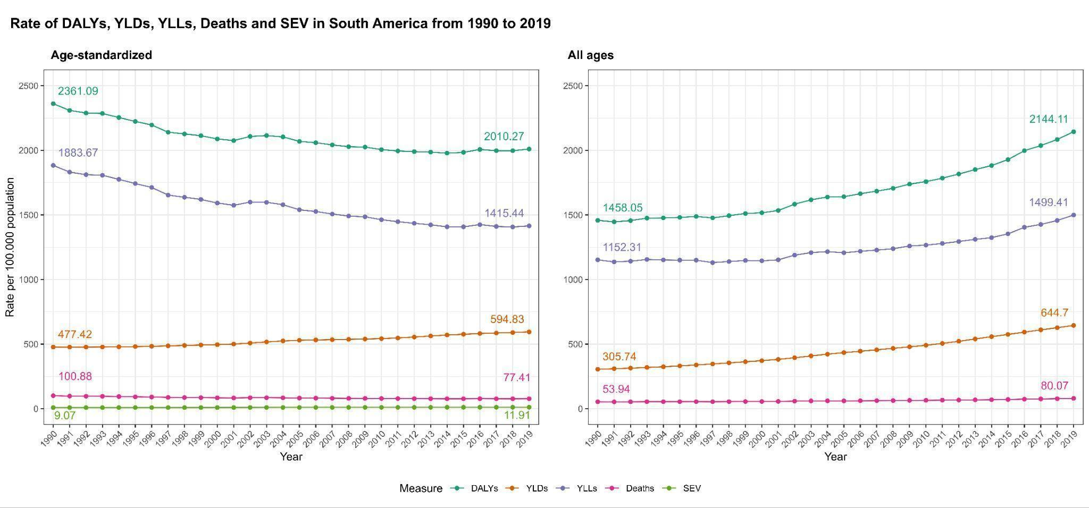

DALYs (disability-adjusted life years), YLLs (years of life lost due to premature mortality), YLDs (years of life lived with disability), SEV (Summary Exposure Value)

**Figure 2.** Age-standardised and all ages annualised rate of change (%) of DALYs, YLDs, YLLs, Deaths and SEV from 1990-2019 in South America countries. **OBS.: deixar FIGURA 2 OU passar para RESUMO GRÁFICO????**

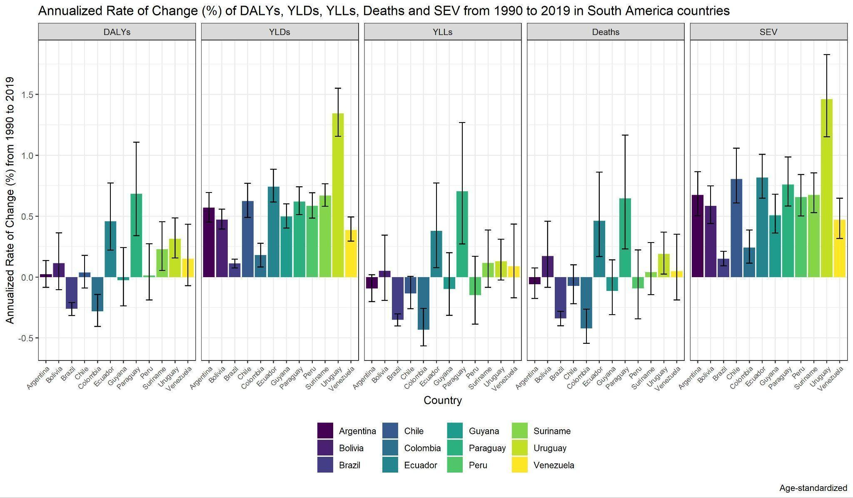

**Figure 3.** Annual rate of change of DALYs, YLDs, YLLs, deaths and SEV through SDI.

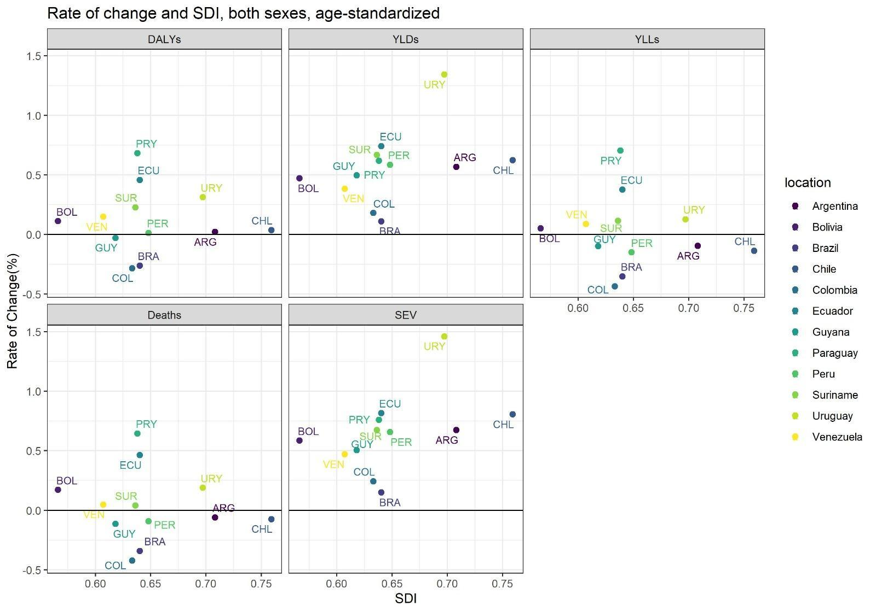

FIGURA 4 SOBRE AS LEADING GLOBAL 15 CAUSES (PRINT??) PARA SUPLEMENTAR. favor conferir se é essa, essa foi um print do gbd, global (nao americas). PRECISAMOS DAS AMÉRICAS.

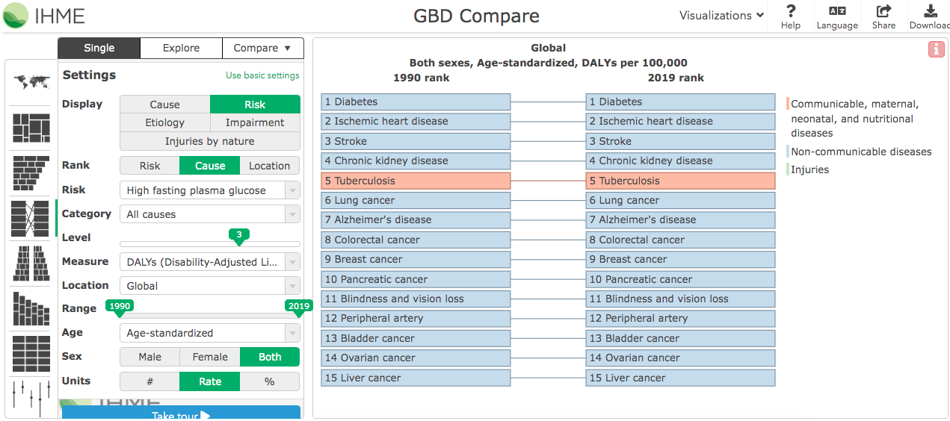

Figura 4: Change in SEV in 1990-2019 for risk factors.

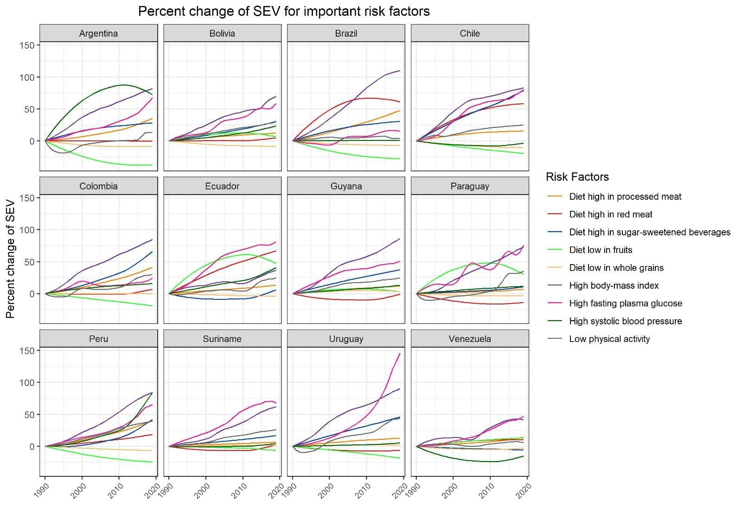

**Discussion**

This study described the age-standardised rates of deaths, DALYs, YLLs, YLDs, and SEV attributable to HFPG in South American countries from 1990 to 2019. South America´s HFPG burden is significant and heterogeneous across countries. While the age-standardized mortality burden has decreased, the underlying cause of the burden – hyperglycemia – has risen, and the combination of a rising prevalence of this risk factor and falling YLLs is producing a shift in burden from premature mortality to living with incapacity.

Our findings showed increased YLDs and SEVs between 1990 and 2019 in this region. The increase of years lived with a disability is related to the rise in prevalence and reflects the impact of HFPG on quality of life prior to leading to death. In other words, people are having more HFPG and living longer with it. SEVs evaluate the population exposure to the HFPG and consider the extent of the exposure by risk level and the severity of HFPG. Our results suggest that the prevalence of HFPG and the average population of the HFPG are increasing. The increase in these estimates is related to increased survival and worsening health behaviours. Low physical activity and poor diet are the two most important risk factors that should be targeted for primary prevention of HFPG and diabetes (3,10–13) **(Cousin E, 2022) (Danaei G, 2011) (PAHO, 2015) (Capewell S, 2018) (Duncan BB, 2017)**. The cost-effectiveness of health-style interventions has been proven favourable to health systems (14) **(Roberts S, 2018)**. Dietary factors are important causes of DALYs worldwide (15) **(Afshin A, 2019)**. The behavioral and metabolic risk factors leading up to HFPG and diabetes increased markedly over the 1990-2019 period in Brazil, with special regard to high body mass index (16) **(Stein C, 2022)**.

The Pan American Health Organization (PAHO) - the regional office for the World Health Organization (WHO) - has been applying the Country Capacity Survey, to assess the preparedness of the countries in various aspects. Pertaining to non communicable diseases, there is access to risk factors data, such as those leading to diabetes. Of the analysed countries in this article, only three (Brazil, Argentina and Chile) had specific diabetes policy, strategy, or national action plan. That comes to show that there might be little structured preventive strategies to combat this disease. On the other hand, the majority of the countries had essential diabetes medicines readily available, as well as guidelines, protocols or standards of care for diabetes treatment. That is, there is little incentive to decrease the disease deflagration, but many resources to deal with it, increasing its prevalence and the time spent with the disease and its associated disabilities (17) **(PAHO Snap)**.

Guyana, Suriname, and Venezuela had the highest DALY values. In contrast, the lowest were found in Peru, Uruguay and Chile. However, the annual rate of change of DALYs, YLLs, YLDs, deaths, and SEV over time showed a shrinking burden in Brazil, Colombia, and Guyana for DALYs, YLLs, and deaths in Argentina, Brazil, Chile, Colombia, Guyana, and Peru. All the countries have a growing burden for YLDs and SEV. These results show the importance of a public policy aimed at preventing HFPG and specific to the different countries of South America. These results could be associated with economic development and the health structures offered in these countries. However, most do not provide a national public health system with excellent coverage.

Furthermore, there was no clear association between the age-standardised deaths, DALYs, YLLs, YLDs, and SEV rate and the annual rate of change in SDI from 1990-2019. Previous studies have demonstrated an inverse correlation between DALYs from HFPG and SDI levels (2) **(Liang R, 2022)**. A possible justification for these differences could be that our data included only South American countries. It seems to be a trans populational phenomenon in South American countries that everybody is susceptible to regardless of the level of development one's in. In previous studies, the DALYs of stroke attributable to HFPG were higher in lower SDI countries (18) **(Liu Y, 2022)**. In contrast, NASH-related liver cancer has increased in the last decades also in regions with high SDI (19) **(Li Z, 2023)**.

The potential sequelae and adverse outcomes that stem from HFPG have personal and public costs. The longstanding association between HFPG and cancer is an example. People with HFPG and diabetes consistently have a higher risk of total mortality (20) **(Wu M, 2021)**. The burden spreads also to non-neoplastic diseases, such as stroke. The global age-standardised rate of DALY attributable to HFPG stroke did not decline significantly from 1990-2019, mainly affecting people over 50 (18) **(Liu Y, 2022)**.

This study is not free of limitations. The main limitation of the GBD assessment of the burden of diseases and injuries is lack of data. Where data are minimal, the results hang on the predictive validity of the modelling attempts. Considering the differences found between the countries of South America, there may be differences between different regions and states of each country. More specific data could further direct the public health policies of each country.

**Conclusion**

South America's high fasting plasma glucose burden is significant and heterogeneous across countries. ~~Besides, there has been an increase in years of living with disability in these countries.~~ The burden of HFPG ~~high fasting plasma glucose~~ is increasing in South America, reflected mainly in years lived with disability and summary exposure value, meaning there has been an increase in years living with disability in these countries.

The rise in HFPG prevalence has brought consequences to both the individual and the public health systems. There was meaningful progress in diagnosis and treatments over the years, but now people live longer with the disease burden. Public health measures urgently need to work on preventing HFPG to avoid its consequences. It is necessary to implement public health policies tailored to each country, to prevent the burden from increasing.

~~South America's high fasting plasma glucose burden is significant and heterogeneous across countries.~~

**Acknowledgements**

**Funding**

This research did not receive any specific grant from funding agencies in the public, commercial, or not-for-profit sectors.

**Competing interests**

None

References

1. Ong KL, Stafford LK, McLaughlin SA, Boyko EJ, Vollset SE, Smith AE, et al. Global, regional, and national burden of diabetes from 1990 to 2021, with projections of prevalence to 2050: a systematic analysis for the Global Burden of Disease Study 2021. The Lancet. 15 de julho de 2023;402(10397):203–34.

2. Liang R, Feng X, Shi D, Yang M, Yu L, Liu W, et al. The global burden of disease attributable to high fasting plasma glucose in 204 countries and territories, 1990–2019: An updated analysis for the Global Burden of Disease Study 2019. Diabetes Metab Res Rev. 2022;38(8):e3572.

3. Cousin E, Schmidt MI, Ong KL, Lozano R, Afshin A, Abushouk AI, et al. Burden of diabetes and hyperglycaemia in adults in the Americas, 1990–2019: a systematic analysis for the Global Burden of Disease Study 2019. Lancet Diabetes Endocrinol. 1o de setembro de 2022;10(9):655–67.

4. Supplementary appendix 1 to: GBD 2019 Risk Factors Collaborators. Global burden of 87 risk factors in 204 countries and territories, 1990-2019: a systematic analysis for the Global Burden of Diseases Study 2019. 17 de outubro de 2020;396(10258):1223–49.

5. Tondro Anamag F, Noori M, Nejadghaderi SA, Sullman MJM, Grieger JA, Kolahi AA, et al. Burden of cancers attributable to high fasting plasma glucose in the Middle East and North Africa region, 1990–2019. Cancer Med. 2023;12(8):10031–44.

6. Wirth JP, Zeng W, Petry N, Rohner F, Glenn S, Donkor WES, et al. The global burden of high fasting plasma glucose associated with zinc deficiency: Results of a systematic review and meta-analysis. PLOS Glob Public Health. 13 de março de 2023;3(3):e0001353.

7. Supplement to: GBD 2019 Diseases and Injuries Collaborators. Global burden of 369 diseases and injuries in 204 countries and teritories, 1990-2019: a systematic analysis for the Global Burden of Disease Study 2019. Lancet. 17 de outubro de 2020;396(10258):1204–22.

8. Ewerton. Supplement to: GBD 2019 Diabetes in the Americas Collaborators. Burden of diabetes and hyperglycaemia in adults in the Americas, 1990-2019: a systematic analysis for the Global Burden of Disease Study 2019. setembro de 2022;10(9):655–67.

9. Murray CJL, Aravkin AY, Zheng P, Abbafati C, Abbas KM, Abbasi-Kangevari M, et al. Global burden of 87 risk factors in 204 countries and territories, 1990–2019: a systematic analysis for the Global Burden of Disease Study 2019. The Lancet. 17 de outubro de 2020;396(10258):1223–49.

10. Danaei G, Finucane MM, Lu Y, Singh GM, Cowan MJ, Paciorek CJ, et al. National, regional, and global trends in fasting plasma glucose and diabetes prevalence since 1980: systematic analysis of health examination surveys and epidemiological studies with 370 country-years and 2·7 million participants. Lancet Lond Engl. 2 de julho de 2011;378(9785):31–40.

11. Organization PAH. Ultra-processed food and drink products in Latin America: Trends, impact on obesity, policy implications. Alimentos y bebidas ultraprocesados en América Latina: tendencias, efecto sobre la obesidad e implicaciones para las políticas públicas [Internet]. 2015 [citado 26 de novembro de 2023]; Disponível em: https://iris.paho.org/handle/10665.2/7699

12. Capewell S, Capewell A. An effectiveness hierarchy of preventive interventions: neglected paradigm or self-evident truth? J Public Health Oxf Engl. 1o de junho de 2018;40(2):350–8.

13. Duncan BB, Schmidt MI, Ewerton Cousin, Moradi-Lakeh M, Passos VM de A, França EB, et al. The burden of diabetes and hyperglycemia in Brazil-past and present: findings from the Global Burden of Disease Study 2015. Diabetol Metab Syndr. 14 de março de 2017;9(1):18.

14. Samantha Roberts. Economic evaluation of type 2 diabetes prevention programmes: Markov model of low- and high-intensity lifestyle programmes and metformin in participants with different categories of intermediate hyperglycaemia. BMC Med. 30 de janeiro de 2018;16.

15. Afshin A, Sur PJ, Fay KA, Cornaby L, Ferrara G, Salama JS, et al. Health effects of dietary risks in 195 countries, 1990–2017: a systematic analysis for the Global Burden of Disease Study 2017. The Lancet. 11 de maio de 2019;393(10184):1958–72.

16. Stein C, Schmidt MI, Cousin E, Malta DC, Naghavi M, Oliveira PPV de, et al. Exposure to and Burden of Major Non-Communicable Disease Risk Factors in Brazil and its States, 1990-2019: The Global Burden of Disease Study. Rev Soc Bras Med Trop. 2022;55(suppl 1):e0275.

17. Country Snapshot of Diabetes Prevention and Control in the Americas. Pan American Health Organization. 2021.

18. Liu Y, Wang W, Huang X, Zhang X, Lin L, Qin J, et al. Global disease burden of stroke attributable to high fasting plasma glucose in 204 countries and territories from 1990 to 2019: An analysis of the Global Burden of Disease Study. J Diabetes. 4 de agosto de 2022;14(8):495–513.

19. Li Z, Yang N, He L, Wang J, Ping F, Li W, et al. Estimates and trends of the global burden of NASH-related liver cancer attributable to high fasting plasma glucose in 1990–2019: analysis of data from the 2019 Global Burden of Disease Study. Diabetol Metab Syndr. 17 de janeiro de 2023;15(1):6.

20. Wu M, Lu J, Yang Z, Shen P, Yu Z, Tang M, et al. Longitudinal changes in fasting plasma glucose are associated with risk of cancer mortality: A Chinese cohort study. Cancer Med. 2021;10(15):5321–8.